**Defect Reports for HealthCare website**

**Defect Report 1**

**Defect identifier B_001**

* **DEFECT SUMMARY :- System accepts invalid name (numeric/special characters) in the name field of form.**
* **TEST ID :- FS_03**
* **TEST CASE NAME :- Name Field Validation**
* **MODULE NAME :- Forms & Submissions**
* **REPRODUCIBLE :- YES**
* **SEVERITY :- Medium**
* **PRIORITY :- Medium**
* **RAISED BY :- Pragati**
* **ASSIGNED TO :- Developer Team Lead**
* **DATE OF ASSIGNMENT :- 01/09/2025**
* **STATUS :- PENDING**
* **SNAP SHOTS :- [Attach screenshot showing invalid name entered and accepted]**
* **FIXED BY :- Developer**
* **DATE OF FIXING :- NA**

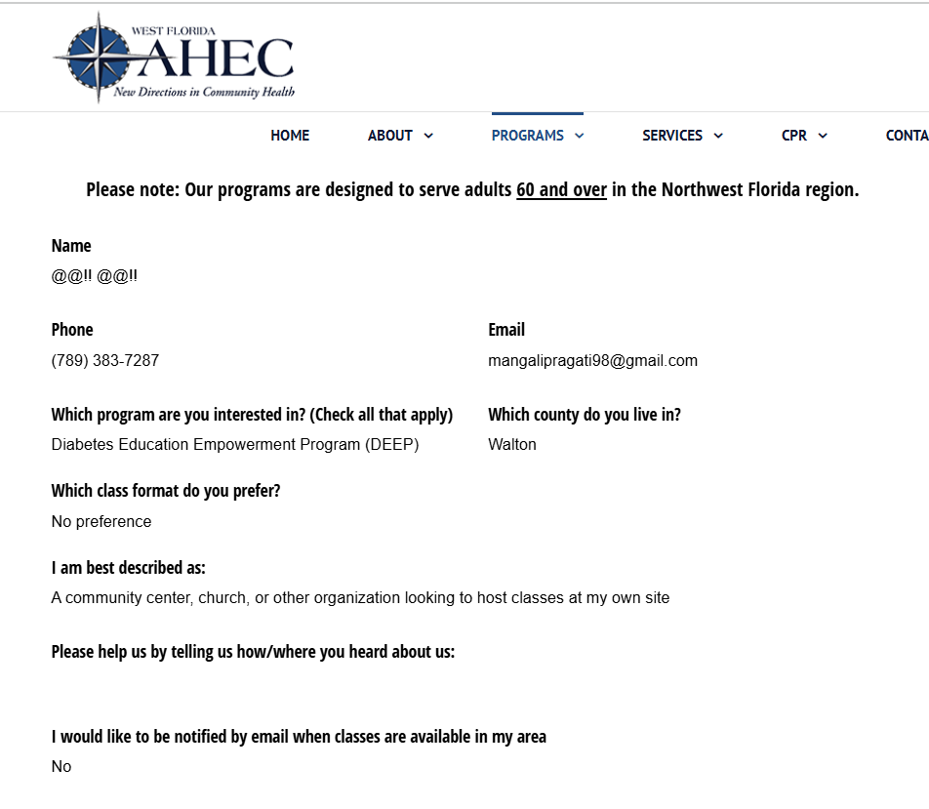

**Defect Report 2**

**Defect identifier B_002**

* **DEFECT SUMMARY :- User did not receive confirmation email after submitting the form.**
* **TEST ID :- FS_07**
* **TEST CASE NAME :- Check Conformation Mail**
* **MODULE NAME :- Forms & Submissions**
* **REPRODUCIBLE :- YES**
* **SEVERITY :- Medium**
* **PRIORITY :- High**
* **RAISED BY :- Pragati**
* **ASSIGNED TO :- Developer Team Lead**
* **DATE OF ASSIGNMENT :- 01/09/2025**
* **STATUS :- PENDING**
* **SNAP SHOTS :- [Attach screenshot of form submission with no confirmation mail received]**
* **FIXED BY :- Developer**
* **DATE OF FIXING :- NA**

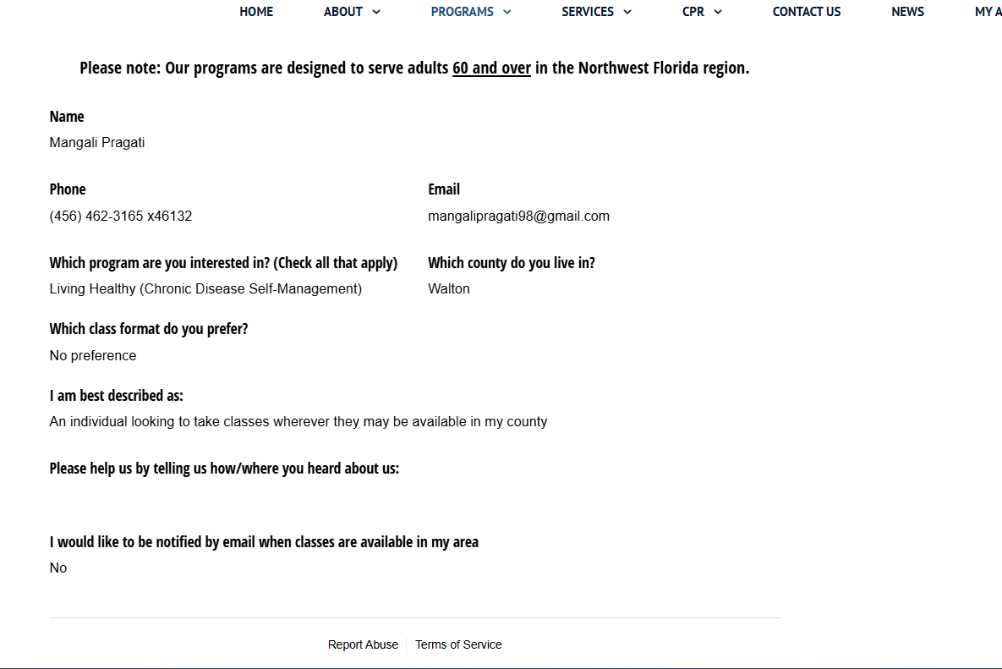

**Defect Report 3**

**Defect identifier B_003**

* **DEFECT SUMMARY :- Message box accepts long strings (>500 characters) without showing an error.**
* **TEST ID :- FS_10**
* **TEST CASE NAME :- Large Input Handling**
* **MODULE NAME :- Forms & Submissions**
* **REPRODUCIBLE :- YES**
* **SEVERITY :- Medium**
* **PRIORITY :- Medium**
* **RAISED BY :- Pragati**
* **ASSIGNED TO :- Developer Team Lead**
* **DATE OF ASSIGNMENT :- 01/09/2025**
* **STATUS :- PENDING**
* **SNAP SHOTS :- [Attach screenshot of message box with >500 characters accepted]**
* **FIXED BY :- Developer**
* **DATE OF FIXING :- NA**

